**Chapter 9 ER Modeling for Database Design**

**Where Is This Chapter Covered In The Course?**

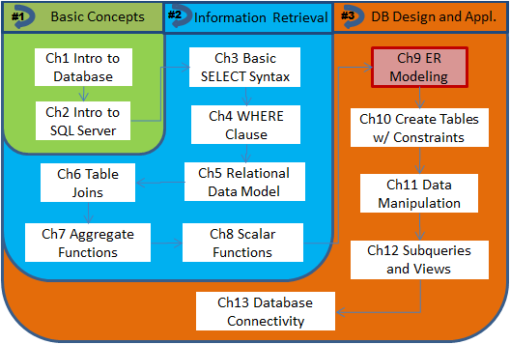

**Chapter Outlines**

Basic Concepts about ER Modeling

Entity

* Attribute
* Graphical notations of attributes

Relationship

* Cardinality

Converting ER Model into Relational Model

* Primary key and candidate keys
* Weak entity type and partial key
* Optionality
* Recursive relationship

More on Design Process

An entity type is denoted as a rectangle A relationship is represented with a line through which (two) entity types are associated with each other. A diamond is required in Chen’s style diagrams,



Figure 9.1 – Basic Notations for Entity and Relationship Types

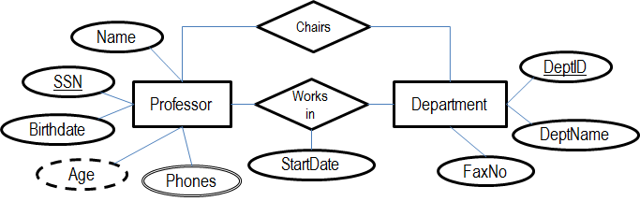

Figure 9.2 - Graphical Notations for Attributes

**Attributes**. An attribute describes a fact about an entity of interest. One example is a Professor’s birth date. An essential activity in ER modeling is to determine all attributes belong to an entity type. Although most attributes have a single simple value, some special kinds of attributes do exist, including:

* ***Composite attribute***: a value that has multiple parts, such as Professor’s *name* may have first name, last name, etc.
* ***Derived attribute***: a value that may be derived from some other attribute in the entity. One example is *age*, which can be derived from birth date.
* ***Multi-valued attribute***: an attribute named *contact numbers* may contain several phone numbers at which a Professor may be accessed.

**Relationship**

Generally speaking, each entity type will become a table in the database, with its attributes as columns. For relationship types, we need to know about their ***cardinality constraints***. Cardinality constraints specify how many instances of related entity types can be associated with each other. There are three possible ways for two entities A and B to be associated:

* ***One-to-one***:
* ***One-to-many/many-to-one***:
* ***Many-to-many:***

**Converting ER Model into Relational Model**

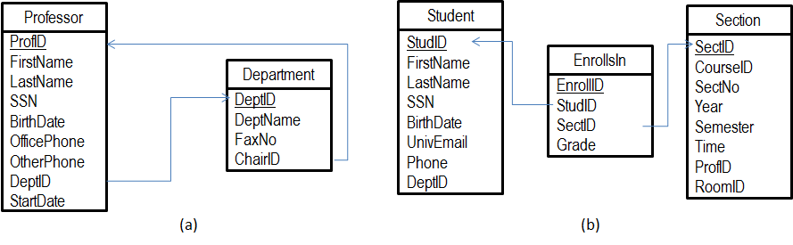

Figure 4 - Relational Models Reduced from ER Diagrams

**Primary key and candidate keys.** A key is a unique identifier that can be used to distinguish instances in an entity set. It may consist one or more attributes. There may be multiple keys exist due to the nature of business data. These unique identifiers are referred to as ***candidate keys***, since each of them can be selected as the ***primary key*** (PK).

In our CIS design, a ***surrogate key*** is assigned to each table as its PK. However, there are other natural candidate keys in many of the tables.

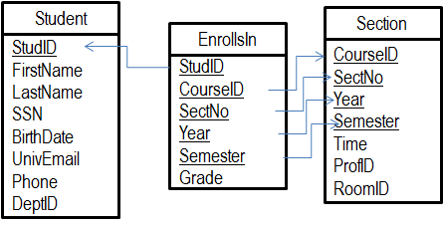

Figure 9.5 - Relational Model Using Only Natural Keys

**Weak entity type and partial key.**

**Optionality.** Another kind of constraints that can be assigned to (participating entity types of) a relationship type is ***optionality***.

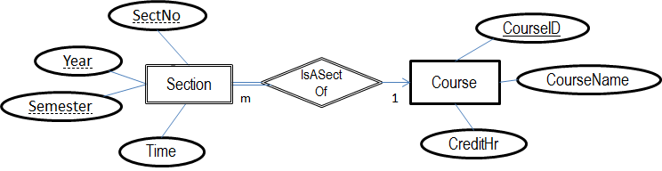

Figure 9.6 - Section Modeled as a Weak Entity Dependent on Course

**Recursive Relationship.**

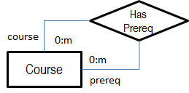 🡺 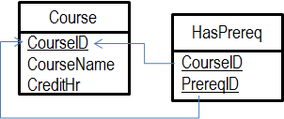

The general process for developing a database project is illustrated with the following steps, aka ADLC



Finally, a complete ER model for CIS is presented as follows. The resultant relational schema will be covered in Chapter 10. SQL statements for creating the tables and setting up constraints (like PK and FK) as well as for modifying data in these tables are introduced in Chapters 10 and 11, respectively.

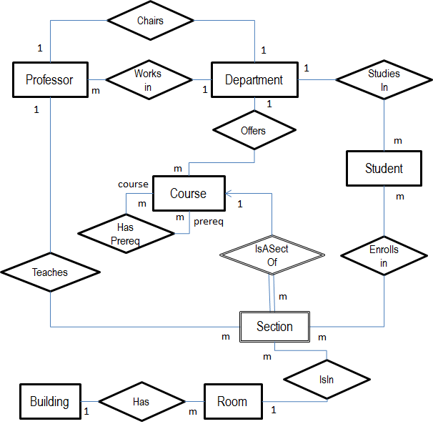

Figure 9.10 - A Complete ER Model for the CIS Database